MOBILE PHONE - STORE MANAGEMENT SYSTEM

Software Requirements Specification
Version 2.0

Danang, Jan 2015

TABLE OF CONTENTS
TABLE OF CONTENTS 2
1. DOCUMENT HISTORY 3
2. REFERENCE DOCUMENTS 3
3. DISTRIBUTION LIST AND APPROVALS 3
4. INTRODUCTION 3
4.1 Purpose 3
4.2 In Scope 3
5. OVERVIEW 4
5.1 Actors 4
5.2 System Use Case Diagram 4
5.3 System Pages Flow 6
6. Functional Description 7
6.1 User interface: 7
6.2 Search: 8
6.3 Add products 9
6.4 Remove products 12
6.5 Update 13
7. NON-FUNCTIONAL REQUIREMENTS AND OTHERS 16
Performance 16
Scalability 16
Security 16
Network 16
Backup and restore 16
Reliability 17
Interfaces 17
User manual and help 17
Extensibility 17
8. APPENDIX 17

DOCUMENT HISTORY
Date | Summary of Changes | Version
22/1/2015 | Release the first version of the SRS document | 1.0
29/1/2015 | These changes followed the comments of stakeholder (i.e. reviewer AnNPT):  - System’s Purpose and Non-Functional Requirements by Binh Pham.  - Overview (diagrams: admin roles and user roles) by Cung Vo.  - Functional Description by Dung Pham.  - Synthesis and Editing by Chanh Le (team leader). | 2.0

REFERENCE DOCUMENTS
Document Name | Description
Software Requirements Specification Order Room Management System | ORMS_SRS_v1.2_EN.docx  Dot Net Team – FPT software
Object Oriented Analysis and Design | Slides  A. Prof. Dr. Nguyen Thanh Binh – IT Faculty, DUT
Software Engineering | Slides  A. Prof. Dr. Nguyen Thanh Binh – IT Faculty, DUT

DISTRIBUTION LIST AND APPROVALS
This document is distributed to the following stakeholders to get their valuable comments and corrections.
Name | Title

INTRODUCTION

Purpose
- This project, Mobile phone store management system is a software allow manager to manage a mobile phone store, to keep staff and every selling activities under control, by this way, he is aware the status of his store, he could manage his budget and come up with a strategy business in order to get a maximum value from that.

In Scope
- The scope pertains to the Mobile Phone - Store Management. It focuses on the store, products, staffs, selling activities, delivering and applications, which allow for online sales, distribution and marketing.
- This SRS is also aimed at specifying requirements of software to be developed but it can also be applied to assist in the selection of in-house and commercial software products. The standard can be used to create software requirements specifications directly or can be used as a model for defining an organization or project specific standard. It does not identify any specific method, nomenclature or tool for preparing an SRS.

OVERVIEW

Actors
The below diagram describes all actors of the Mobile Phone - Store Management System. An actor represents a User Role; currently we have Administrator and Normal User Account. Each user has his own actions when accessing into the system.

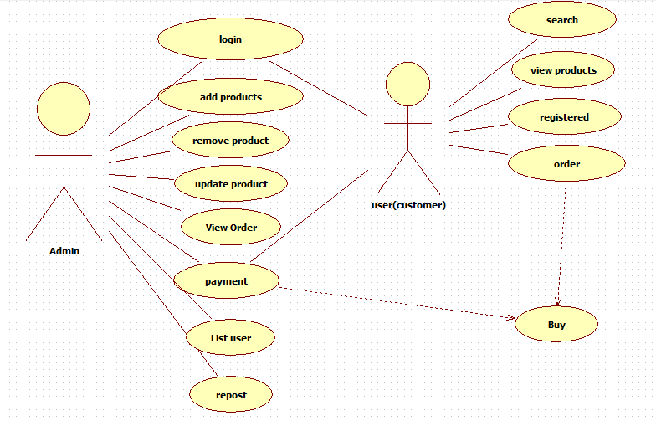
Actor | Description
Administrator | Has the right to View, Add new, Update and Delete data in all modules.
Normal User Account | Has the right to View, Add new, Update and Delete data in all modules, except User Accounts Maintenance.

System Use Case Diagram
The following diagram provides an overall picture of the functionality groups, Actors of the Mobile Phone - Store Management System. Mobile Phone - Store Management System’s functionalities are divided into these use cases:

Admin Roles
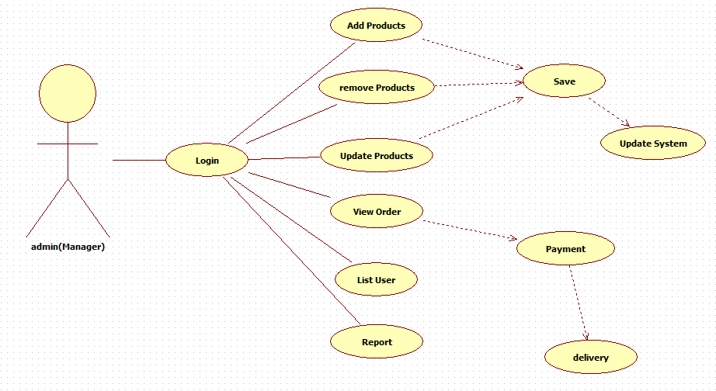

User Roles
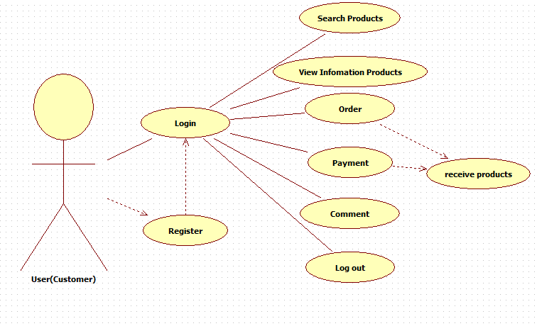

System Pages Flow
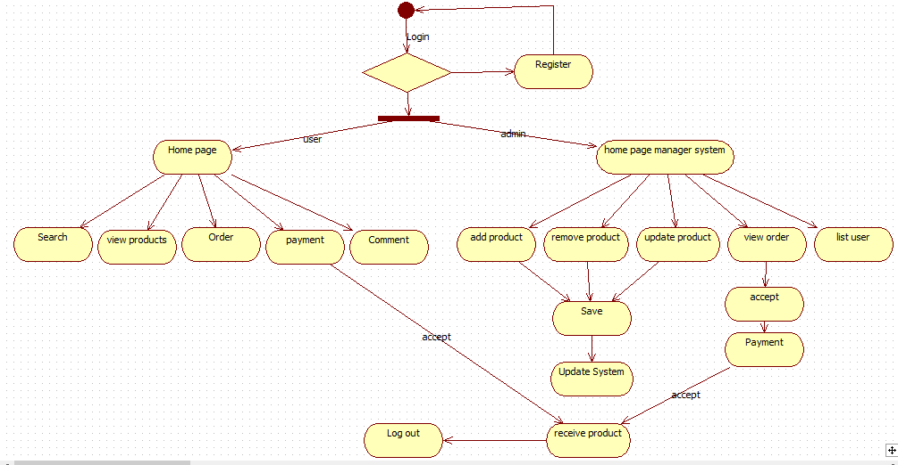

Functional Description

User interface:
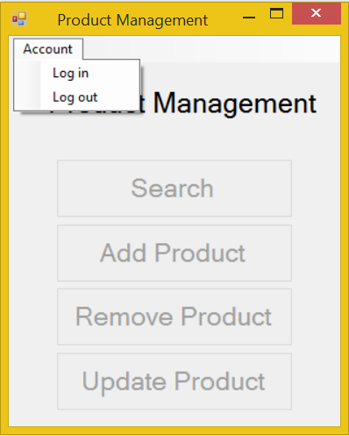
Screen | Product Management – User interface
Description | Display a screen where user can control the product.
Screen Access | Users run program by click on file ProductManagement.exe
Screen Content
Item | Type | Data | Description
Product Management | Label |  | Name of the software
Account | Menu strip item |  | Name of menu strip
Log in | Menu strip item |  | Open a dialog where user can log into program
Log out | Menu strip item |  | Log out the program.
Search | Button |  | If user click on this button, the “Search” dialog will appear.
Add Product | Button |  | If user click on this button, the “Add Product” dialog will appear.
Remove Product | Button |  | If user click on this button, the “Remove Product” dialog will appear.
Update Product | Button |  | If user click on this button, the “Update Product” dialog will appear.
Screen Actions
Action Name | Description |  | Success | Failure
Log in | Everyone have an account and click on it to enter the system. |  | Username of current user will display at the bottom of screen and all buttons will be enabled. | Displays message “Username or password is incorrect.”
Log out | Use to exit the system. |  | Username of current user at the bottom of screen will be disappeared and all button will be disabled. | Nothing.
Search | Search data which existed in database |  | “Search” dialog opened | Nothing.
Add Product | Add more data. |  | “Add Product” dialog opened | Nothing.
Remove Product | Remove some of data. |  | “Remove Product” dialog opened | Nothing.
Update Product | Update some exist fields of data. |  | “Update Product” dialog opened | Nothing.

Search:
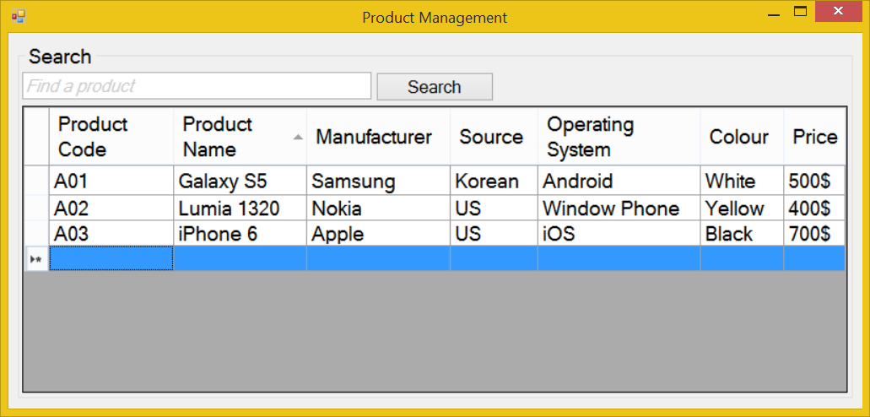
Screen | Product Management - Search
Description |  | Display a textbox and a button for “Search” function with the available data displayed in the data grid view below them.
Screen Access |  | Users run program then click on Search button
Screen Content
Item |  | Type | Data | Description
Data grid view |  | Datagridview | Lookup all fields from PRODUCT table. | - Display all fields about the product when the form loaded: Product code, product name, manufacturer, source, OS, colour, price.  - This table is read-only, user cannot edit it.
Find a product |  | Text field – String (50) |  | Allow user enter the data to search.
Search |  | Button |  | User click on it to search
Screen Actions
Action Name |  | Description |  | Success | Failure
Search |  | Find a product in the table below. |  | Return the result of searching process | Message “Not found”.
The shop must ensure that the customers can easily find the exact product they need.
The customer can find their desire product in the catalogue or listen to shop agent’s advices. The catalogue must be updated frequently, accurately, clearly, must be a computer-typing, try to avoid write it down by hand. Inside the catalogue, the shop can classify the products according to manufacturer, pricing… and more.
The shop’s agent check out the customer’s choice, if it available then create an export receipt. If not, the agent must say apologize to the customer and require he (or she) chooses another products.

Add products
Use Case Name | Add products
Use Case ID | ABC001
High Level Requirement Ref | The general information about imported products must be prepared. The manager and the others members who have authority can view the product list. Besides that, they can make the order to import more products.
Actor | Shop’s Master, Warehouse Manager, Treasurer, Accountant
Description | This use case is used to add more products.
Pre-condition | The product is not available in the database.
Post-processing | The database has new products.

Screen Design

Add products – Filter
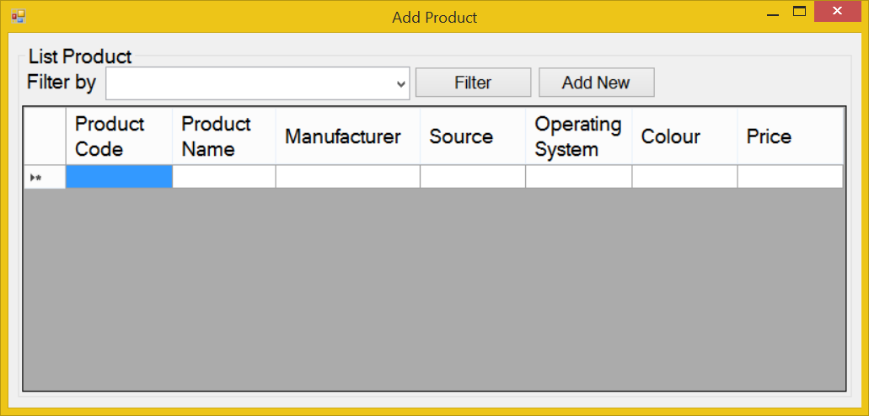
Screen | Add products – Filter
Description |  | Display query screen to filter displayed results. The system displays all products information from the DB, on the screen. Then users can choose to display any product information, by choosing value in dropdown lists of “Filter by”.
Screen Access |  | Users run program and click on the button Add Products
Screen Content
Item |  | Type | Data | Description
Filter by |  | Dropdown list - Alpha numeric (5) | Default: All.  Lookup from PRODUCT table by value inputted in the dropdown list. | User can choose the filter item from dropdown list to filter the displayed result, such as product code, name, OS, etc.
Filter |  | Button |  | Execute the filter
Add New |  | Button |  | User click on it to add a new product to the database.
Screen Actions
Action Name |  | Description |  | Success | Failure
Filter |  | List of all products will be ordered by PRODUCT.NAME.  When users choose any value in the above dropdown list and click Filter button then the system returns data of that product. |  | Display general data of inputted Product code (data is selected from table PRODUCTS). | Displays message “No data found.” in the Message Area.
Add new |  | Add new product to the database |  | Open Add Product dialog | Nothing.

Add products – Add new
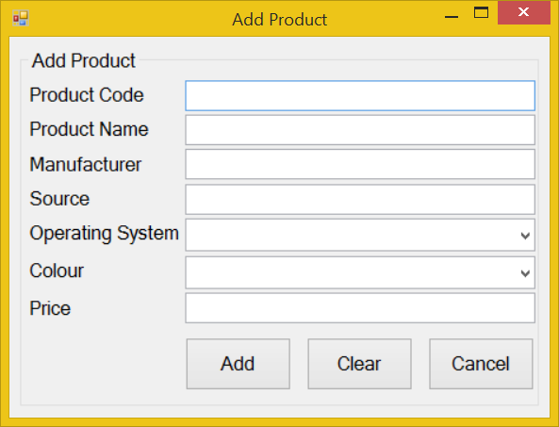
Screen | Add products
Description |  | Allow Administrator and Managers Account to add new products.
Screen Access |  | Users click on the button Add Product -> Add New
Screen Content
Item |  | Type | Data |  | Description
Product Code |  | Text field – Alpha numeric (5) | Inserted into PRODUCT.CODE |  | This field is mandatory.
Product Name |  | Text field – String (45) | Inserted into PRODUCT.NAME |  | This field is mandatory.
Manufacturer |  | Text field – String (45) | Inserted into PRODUCT.MANU |  | This field is mandatory.
Source |  | Text field – String (45) | Inserted into PRODUCT.SOURCE
Operating System |  | Dropdown list – String (45) | Inserted into PRODUCT.OS |  | This field is mandatory.  User choose the OS from available item in the dropdown list, if there’re any OS that not exist in the list, user can choose “Other”.
Colour |  | Dropdown list – String (45) | Inserted into PRODUCT.COLOUR |  | User choose the Colour from available item in the dropdown list, if there’re any Colour that not exist in the list, user can choose “Other”.
Price |  | Text field – Number (45) | Inserted into PRODUCT.PRICE |  | This field is mandatory.
Clear |  | Button |  |  | Clear all inputted data.
Add |  | Button |  |  | Add inputted data into database
Cancel |  | Button |  |  | Cancel to add new and back to “List” screen.
Screen Actions
Action Name |  | Description |  | Success | Failure
Add |  | Inputted data will be saved into the DB. |  | Back to the “Add Product” screen with new record on the table below (default list with all data).  When go back to the list from “Add Product” screen, the new record will be focused on. | Display message: “Database connection error.”  Display message “The product code is already exist in the system. Please enter a new product code.”  Display message:  “Product Code must be entered.”  Display message:  “Product Code must be in the format of alpha numeric”.  Display message:  “Product Name must be entered.”  Display message:  “Manufacturer must be entered”.  Display message:  “Price must be entered.”  Display message:  “Price must be a number”  Display message:  “Operating system must be chosen”.
Clear |  | Clear inputted data. |  | Display “Add New” screen with blank data. | Nothing.
Cancel |  | Close “Add” screen. |  | Return to the “Add product” screen (default list with all data). | Nothing.

Remove products

Screen Design

Remove product:
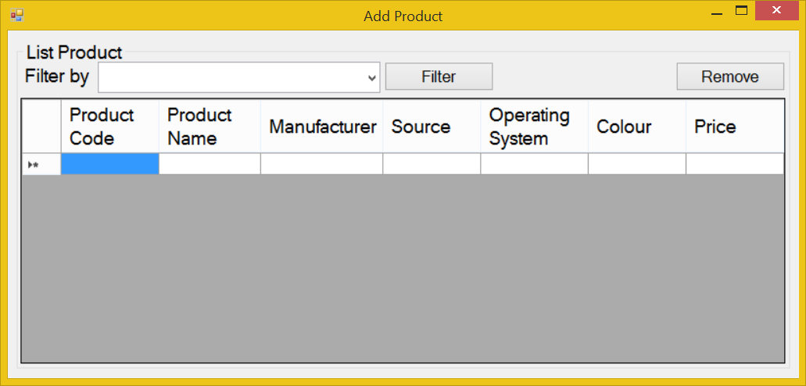
Screen | Remove product – Filter & Remove
Description |  | Display all products information base on the input field in the Filter
Screen Access |  | Users run the program and click on Remove products
Screen Content
Item |  | Type | Data |  | Description
Filter by |  | Dropdown list - Alpha numeric (5) | Default: All.  Lookup from PRODUCT table by value inputted in the dropdown list. |  | User can choose the filter item from dropdown list to filter the displayed result, such as product code, name, OS, etc.
Filter |  | Button |  |  | Execute the filter
Remove |  | Button |  |  | User click on it to remove a product chosen from the table below.
Screen Actions
Action Name |  | Description |  | Success |  | Failure
Filter |  | List of all products will be ordered by PRODUCT.NAME.  When users choose any value in the above dropdown list and click Filter button then the system returns data of that product. |  | Display general data of inputted Product code (data is selected from table PRODUCTS). |  | Displays message “No data found.” in the Message Area.
Remove |  | - If the user logged in is Administrative or Manager Account, then Product Code are displayed as links.  - The user clicks on the item in the data grid view, then click on the “Remove” button to remove it. |  | “Remove” pop up is displayed and ask user to confirm the command. |  | Displays message “Cannot remove the product.”

Update
- Change the basic information of products (manufacturer, colour, source…)
- Change the product’s price.
- Add or remove special offer announcement.
- Update the product’s quantity.
- Update the product’s status.

Screen design:

Update product - Filter:
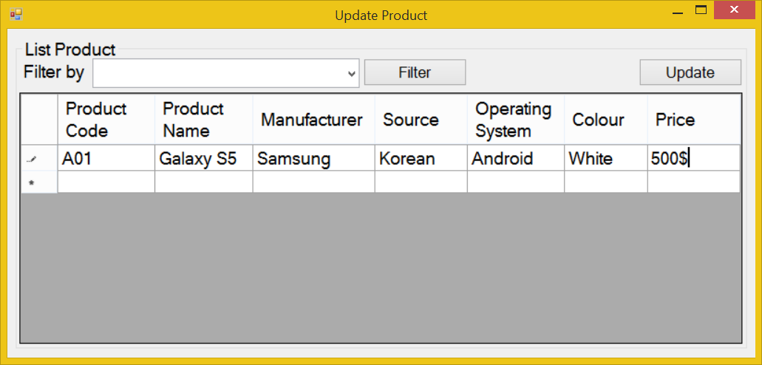
Screen | Update product – Filter
Description |  | Display all products information base on the input field in the Filter
Screen Access |  | Users run the program and click on Update products
Screen Content
Item |  | Type | Data |  | Description
Filter by |  | Dropdown list - Alpha numeric (5) | Default: All.  Lookup from PRODUCT table by value inputted in the dropdown list. |  | User can choose the filter item from dropdown list to filter the displayed result, such as product code, name, OS, etc.
Filter |  | Button |  |  | Execute the filter
Update |  | Button |  |  | User click on it to update a product chosen from the table below.
Screen Actions
Action Name |  | Description |  | Success |  | Failure
Filter |  | List of all products will be ordered by PRODUCT.NAME.  When users choose any value in the above dropdown list and click Filter button then the system returns data of that product. |  | Display general data of inputted Product code (data is selected from table PRODUCTS). |  | Displays message “No data found.” in the Message Area.
Update |  | - If the user logged in is Administrative or Manager Account, then Product Code are displayed as links.  - The user clicks on the item in the data grid view, then click on the “Update” button to remove it. |  | “Update Product” dialog will be displayed in order for user to edit the product’s information. |  | Nothing.

Update product - Update:
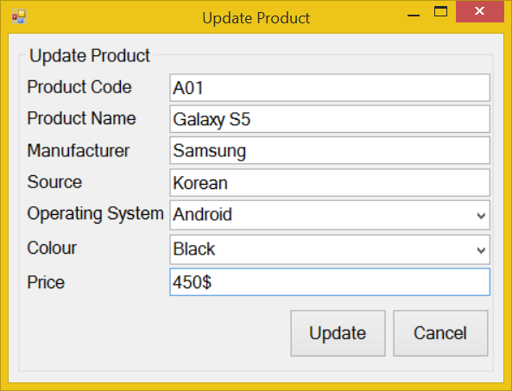
Screen | Update products
Description |  | Allow Administrator and Managers Account to update existing records.
Screen Access |  | Users run program and click on the button Update Product -> Updates
Screen Content
Item |  | Type | Data |  | Description
Product Code |  | Text field – Alpha numeric (5) | This field is unique for each products.  Look up from PRODUCT.CODE |  | This field is mandatory.  A sequence number that auto generated by database will be used as foreign key to join primary table and reference table.  So that, when we update value of any item in the main table, then that value can be referenced by other tables using foreign key.
Product Name |  | Text field – String (45) | Look up from PRODUCT.NAME |  | Display the name of products.  This field is mandatory.
Manufacturer |  | Text field – String (45) | Look up from PRODUCT.MANU |  | Display the name of manufacturer.  This field is mandatory.
Source |  | Text field – String (45) | Look up from PRODUCT.SOURCE |  | Display the source of manufacturer.
Operating System |  | Text field – String (45) | Look up from PRODUCT.OS |  | Display the OS of manufacturer.  This field is mandatory
Price |  | Text field – Number (45) | Look up from PRODUCT.PRICE |  | Price of product.  This field is mandatory
Colour |  | Text field – String (45) | Look up from PRODUCT.COLOUR |  | Colour of product.
Update |  | Button |  |  | Submit data.
Cancel |  | Button |  |  | Cancel update.
Screen Actions
Action Name |  | Description |  | Success | Failure
Update |  | Updated data will be saved into the DB. |  | Back to the “Update Product” screen with updated record on the list.  If the user choose to update a product from the list of all products, then when go back to the list from update, the updated record will be focused on. | Display message “The selected record has been removed by someone.”  Display message “The selected record has been changed by another user! Please refresh to get the latest data for your update.”  Display message: “Database connection error.”  Display message:  “Product Code must be entered.”  Display message:  “Product Code must be in the format of alpha numeric”.  Display message “The product code is existed in the system. Please enter a new product code.”  Display message:  “Product Name must be entered.”  Display message:  “Manufacturer must be entered.”  Display message:  “Operating System must be chosen from the dropdown list.”  Display message:  “Price must be entered.”
Cancel |  | Close “Update” screen and return to the list. |  | Return to the “Update Product” screen. | Nothing.

NON-FUNCTIONAL REQUIREMENTS AND OTHERS

Performance
No. | Requirement
1. | Allow at least 10 users access at the same time
2 | Can run on computer with 512MB of RAM or higher, 1.7 GHz of CPU or higher, Windows XP 32bit or higher
3 | Used maximum 256MB of disk space (not include database)

Scalability
No. | Requirement
1. | Allow admin to limit the maximum of user access the system at the same time
2 | Allow developer to add more type of user with the different authority
3 | Allow admin to create more user account

Security
No. | Requirement
1. | Protect customer information
2. | Ensure the integrity, security of data
3 | Decentralize the user
4 | Protect internal information
5 | The system’s back-end databases shall be encrypted.

Network
No | Requirement
1 | Allow the manager to manage the store from home using the internet

Backup and restore
No | Requirement
1 | The system can synchronize automatically every day
2 | In case the system get error, it can restore, back to the status before getting error

Reliability
No | Requirement
1 | Only administrator can change product information
2 | Every changed of price have to be confirmed by the manager
3 | The system shall provide storage of all databases on redundant computers with automatic switchover.

Interfaces
No. | Requirement
1. | Font style is the same with http://www.customer.com.sg/default.aspx
2 | The GUI must have no more than 10 buttons each form
3 | The menu must have no more than 5 submenus
4 | Use the fresh color like the yellow green, blue, green, yellow .etc.

User manual and help
No | Requirement
1 | The software shall show the Use guide in the first running
2 | The software shall have a Help menu to show the Use guide in case users don’t know how to use or what is the purpose of the function

Extensibility
No. | Requirement
1. | Can add more table record without conflictions with the older
2. | Allow the developer to add more functions without conflictions
3 | The software can provide data to other application on other platform

APPENDIX

